AAU Bus Tracking System

Functional Requirements
Student Interactions
- The system shall allow a Student to view bus details (e.g., location, status, route).
- The system shall provide a mechanism for the Bus System Interface to show updates (e.g., real-time location changes, trip status) to the Students.
- The system shall allow Students to view trip detail (stops, route).
- The system shall allow Students to use a chatbot.
- The system shall allow Students to confirm their trips if the capacity allows it.

Driver Interactions
- The system shall allow a Driver to update bus detail (e.g., route deviation, passenger count).
- The system shall allow a Driver to update location (e.g., real-time GPS coordinates).
- The system shall allow a Driver to update status (e.g., 'On Trip', 'At Stop', 'Delayed').
- The system shall allow a Driver to signal the End trip.
- The System shall allow Driver to view all the updates on the Bus System Interface.
- The system shall allow a Driver to view bus details (e.g., location, status, route).
- The system shall provide a mechanism for the Bus System Interface to show updates (e.g., real-time location changes, trip status) to the Driver.

Admin Interactions
- The system shall allow an Admin to update bus detail (e.g., route assignments, capacity).
- The system shall allow an Admin to update status (e.g., bus 'Out of Service', 'Scheduled Maintenance').
- The system shall allow an Admin to Add/Delete/View bus records within the system.
- The system shall allow an Admin to Add/Delete/Update/View Drivers records.
- The system shall allow an Admin to Add/Delete/Update/View Students records.
- The system shall ensure that administrative changes to bus details are sent to and stored in the University Bus System.
- The system shall display updated bus details and Display changes to the Admin after administrative actions are performed.
Non-Functional Requirements
- Security:
  - The system shall ensure that only authenticated Drivers can update location and status.
  - The system shall ensure that only authenticated Admins can perform maintenance operations (Add/Delete/Update of buses, drivers, and students).
  - The system shall separate the user’s rights based on their tokens(admin, student, driver).
- Performance:
  - The system must display real-time location updates to the users within a few seconds.
- Usability:
  - The Bus System Interface must be intuitive and easy to use for the Driver to quickly and safely update location and status while operating the bus.

1. Introduction
- 1.1 Purpose and Scope
  - Purpose: A system to track the universities busses in real time.
  - Scope: The system will track location, time, and status of each bus, and will allow all users to view this information. The drivers will be able to update the status of their own bus, and the admin will be able to have full administrative capabilities over the entire system, including managing the users.
- 1.2 Goals and Constraints
  - Goals: Fast real-time location updates, high availability, maintainable codebase.
  - Constraints: Use of FastAPI (Python) for the backend, React for the frontend, Supabase for the database/auth, and Google Maps API for the map functions.
- 1.3 Definitions and tools:
  - Supabase: Simplifies the stack by combining a scalable PostgreSQL database with essential Real-Time capabilities (for bus locations) and Auth management, eliminating the need to build these services from scratch.
  - React: It is the industry standard for modern, modular, and maintainable UIs. Its component-based architecture is perfect for building complex views like the Admin dashboard or the Student map view.
  - FastAPI: Python web framework for building the backend API. Used for its High Performance, which is crucial for handling frequent, concurrent Driver location updates and Student data requests efficiently. The automatic Swagger/OpenAPI documentation drastically speeds up frontend-backend integration.
  - Alembic: Ensures safety and repeatability of database changes. This is vital when adding new features (like Schedules or Stops to production without data loss or downtime.
  - Axios: HTTP client for frontend requests.
  - Google Maps API: Provides reliable, high-accuracy geographical data and robust features which are essential for a professional tracking system.

2. System Architecture
This section illustrates the system's structure and the flow of data.

2.1 High-Level View (3-Tier Architecture)
  - The system follows a standard 3-Tier Architecture:
    - Presentation Tier: All user interfaces (React).
    - Application Tier: The core business logic and API (FastAPI).
    - Data Tier: Database, authentication, and storage (Supabase).
2.2 Component Diagram(styled componets)
A. Presentation Layer (React)
    - Student Portal: Built with React and styled with MaterialUI 4. Uses Axios for API calls.
    - Driver Portal: Built with React. Handles real-time location submission.
    - Admin Portal: Built with React. Interface for CRUD operations.

B. Application Layer (FastAPI)
    - Primary Role: Acts as a secure gateway, handling business logic, data validation, and authentication.
    - API Documentation: Exposed via Swagger UI (automatically generated by FastAPI).
C. Data Layer (Supabase)
    - Database: PostgreSQL for structured data with Realtime functionality, database backups, extensions (Bus, Driver, Student records).
    - Authentication: Managed by Supabase and programmed using Python.
    - Real-Time Updates: Location updates is stored as JSON and synchronized by firebase in realtime to every connected client.

3. Technology Stack & Decisions
Component | Tool | Details
Backend API | FastAPI (Python) | To handle all data operations (CRUD for Admin), manage Login/Registration, and serve the initial routes and schedules data to the frontends.
Database & Auth | Supabase (PostgreSQL) | Provides a scalable, managed database and built-in services, simplifying the stack.
Frontends | React | To build the user interface for the three distinct actors (Student, Driver, Admin), ensuring a dynamic and responsive user experience.
Styling | MaterialUI 4 | Provides pre-built, high-quality, responsive UI components for fast development.
HTTP Client | Axios | To manage structured, reliable communication between React and FastAPI.
Database Migrations | Alembic | Database migration tool to define database schema changes and ensure they have the same structure
Mapping | Google Maps API | To display the real-time location of buses, plot the Routes, and calculate estimated travel times for Students.

5. Diagrams
- 5.1 Sequence diagrams
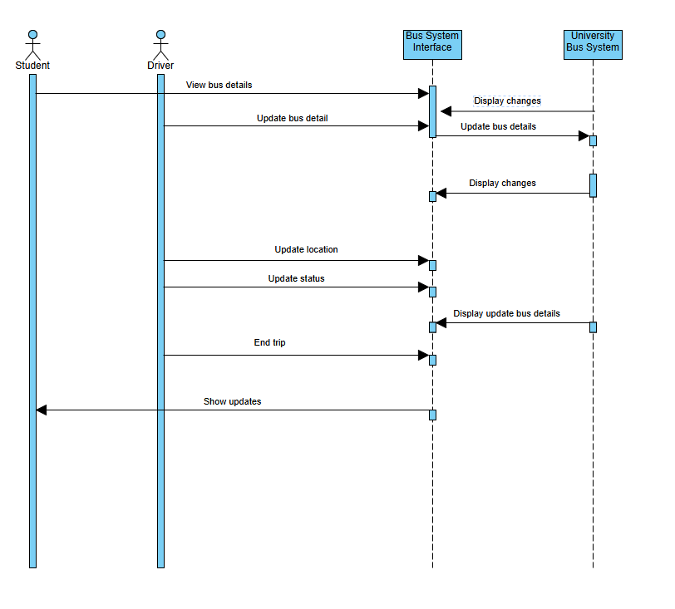
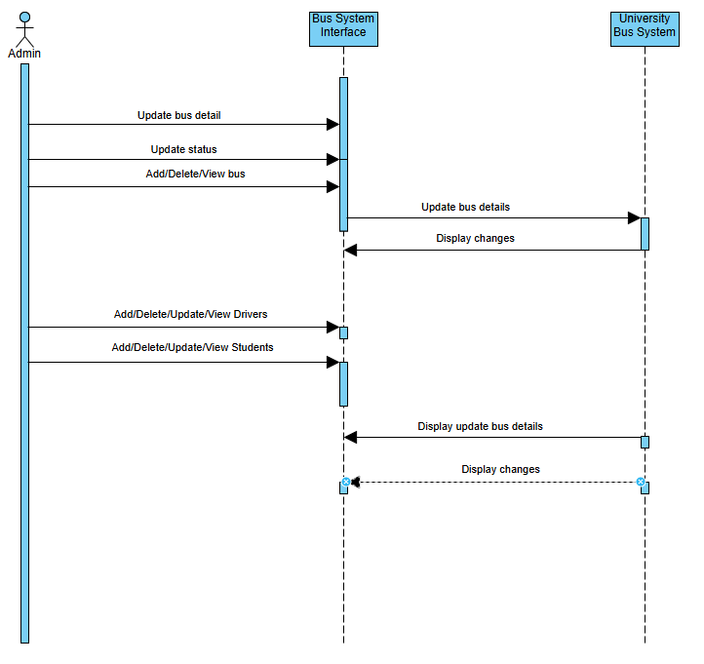

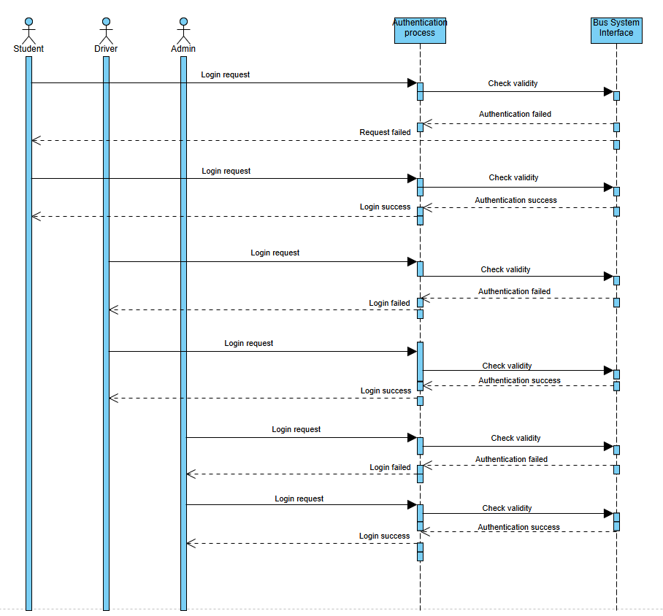

- Use Case Diagrams
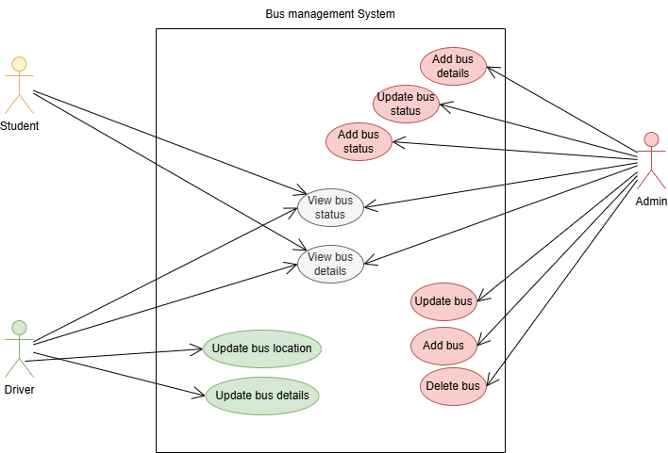
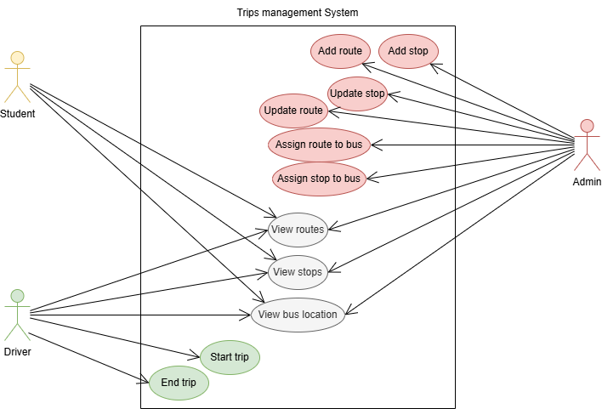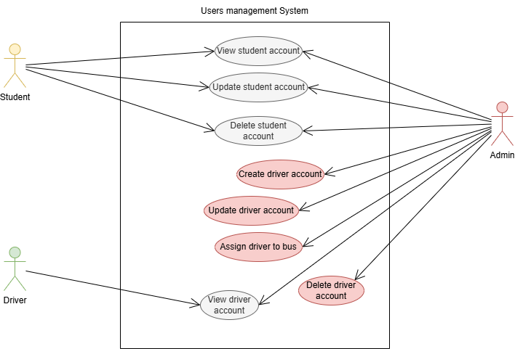
- Database diagram
